|  |  |  |  |
| --- | --- | --- | --- |
| 1 | | 820,176.0 | |
| NUMERO DE FRONTERAS | | ENERGIA AGREGADA | |
|  | | | |
| SI | | 21-04-2020 | |
| CONTRATO | | VENCIMIENTO CONTRATO | |
|  | | | |
| 123,996,003 | 26 | | 4,992,000 |
| INGRESO 2020 | DÍAS CERTIFICADOS 2020 | | ENERGIA RESPALDADA 2020 |
|  | | | |
| 1,913,909,718 | 173 | | 82,309,114 |
| INGRESO 2021 | DÍAS CERTIFICADOS 2021 | | ENERGIA RESPALDADA 2021 |

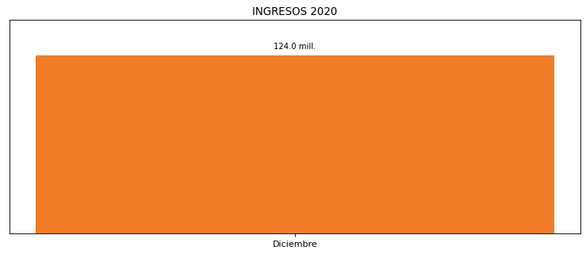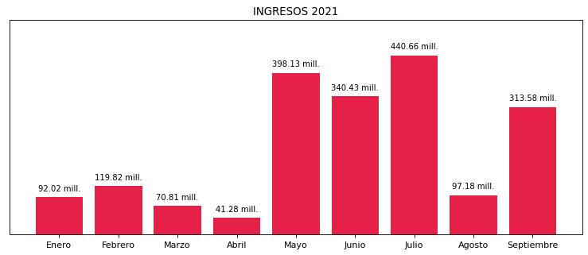

|  |
| --- |
| **FRONTERA ENERGY**  USUARIO |

|  |
| --- |
| **Mateo Porras**  Ejecutivo de cuenta |

|  |
| --- |
| **0**  PUNTO FOCAL |

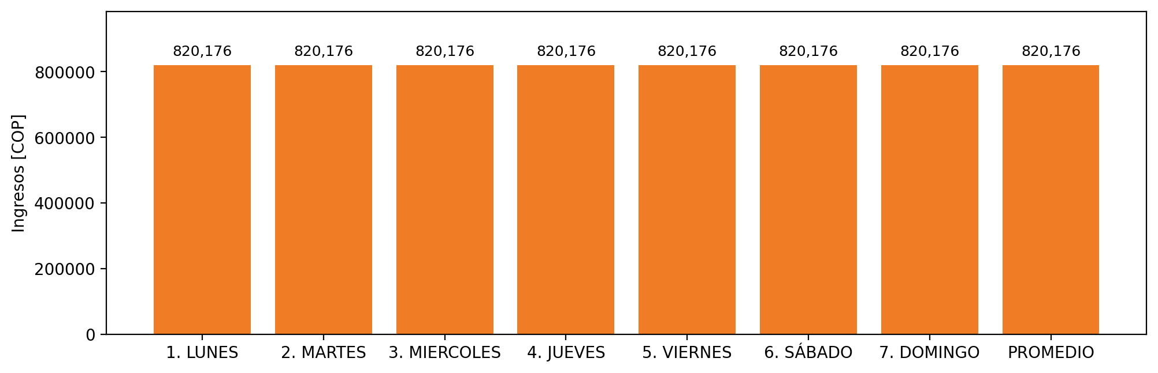

|  |  |  |  |  |  |  |  |  |  |  |
| --- | --- | --- | --- | --- | --- | --- | --- | --- | --- | --- |
| **FRONTERA** | **COD SIC** | **PREDIO** | **FRT DDV** | **TIPO DDV** | **PROMEDIO** | **PRÓXIMA ACTUALIZACIÓN** | **MARGEN DE ERROR** | **ÚLTIMA PRUEBA DDV** | **DÍAS PARTICIPACIÓN** | **FECHA REFERENCIA PRÓXIMA PRUEBA DDV** |
| Quifa III - Quifa IV | Frt24197 | Prd01936 | Frt37374 | LBC | 820,176 | 2022-03-04 | 4,31 | 2021-08-11 | 29.0 | 2021-12-29 |